PROJECT REPORT
“Design Of Single Cylinder Engine Assembly”

(REPORT SUBMITTED FOR THE PARTIAL FULFILMENT OF THE
REQUIREMENT FOR THE THREE YEAR DIPLOMA IN
“Mechanical (Production)”

SUBMITTED TO
“Feroze Gandhi Polytechnic”
Raebareli

SUBMITTED BY:
Abhishek Ji

(College Enrolment Number-E21222434300008)
2023-2024



Under the Guidance of
Er. Akhil Srivastava
Trainer and Project Manager
SOFTPRO INDIA COMPUTER TECHNOLOGIES (P) LTD.

SOFTPRO INDIA


COMPUTER TECHNOLOGIES PVT.LTD.

(AN ISO 9001:2015 CERTIFIED COMPANY)

SPI/VTME/2023/037

Certificate of COMPLETION

This is to certify that Mr. /Ms.Adarsh Singhof Diploma [Mechanical (Automobile)]from Government Polytechnic Jamunia Deeh Harakh, Barabankiwas working on the project entitled “Design of Single Cylinder Engine Assembly” in Softpro India Computer Technologies (P)Ltd. She/he was engaged with us for training during Julyto August for one and a half month.

He/She has done an excellent job during his/her engagement with the Software Development & Testing Division of the company. She/he has completed his/her project during the training tenure. His/her performance has been good and satisfactory.

I would like to take this opportunity to express my appreciation to Mr./Ms. Adarsh Singhfor his/her work and wish him/her all the very best for his/her future endeavours.

Regards,

Ms. Yashi Asthana
C.E.O
Softpro India Computer Technologies (P) Ltd.
Lucknow (U.P.)

DECLARATION

I, <Abhishek Ji>, hereby, declare that the Project Report submitted to <Feroze Gandhi Polytechnic, Raebareli> for the award of a three-year Diploma in <[Mechanical (Production)]>was done under the guidance of Er. Akhil Srivastava,Senior Consultant, Softpro India Pvt. Ltd. I also declare the information in the report is correct as per my knowledge and I bear any responsibilities for any error or omission, if any. The matter embodied in this project work has not been submitted earlier for the award of any degree or diploma to the best of my knowledge and belief.

Student Name

Date:

Acknowledgement

I would like to express my sincere gratitude to my trainer and mentor Er. Akhil Srivastava,Senior Consultant –CE/ME Department (Softpro India Computer Technologies (P) Ltd.), who gave me his full support and encouraged me to work in an innovative and challenging project for the Educational field. His knowledge and guidancewere extremely helpful in completion of my training. I would also extend my thanks to every member of Softpro India Computer Technologies (P) Ltd. for their support and co-operation.

Student Name

INDEX

S.No. | Topic | Page No.
1 | About the Organisation
2 | About Industrial Training
3 | About AutoCAD
4 | About Solidworks
5 | Introduction to the Project  - Abstract  - Literature Reviews  - Objectives
6 | About the Project  - Specifications  - Methodology
7 | Results
8 | Conclusion

- ABOUT THE ORGANISATION

Softpro India Computer Technologies (P) Ltd. is a leading IT firm and the software development division of Softpro Group of Companies with its headquarter located in the capital city of Uttar Pradesh, Lucknow. Technocrats from IIT-Kanpur and IET Lucknow established Softpro India in 2004. Softpro Group of Companies is a cluster of companies working in multiple domains like Software Development, IT Trainings, Research and Designing.
The Founder and Managing Director of Softpro Group of Companies is Er. Ajay Chaudhary with over 25 years of experience. Softpro India is the fastest growing IT company with the largest learning center of the region with 15+ years experienced consultants and industry experts.
Softpro Group of Companies compromises of Softpro India Computer Technologies (Software Development division), Softpro Learning Center (Training & Internship division – 2008), Softpro Innovations (Research &Development division – 2014) and Softpro Foods (Agro Production division – 2018). Softpro India has global presence with its Head Office and Training Center located in Lucknow, International Unit Office – Softpro Technologies, located in Malawi, Africa and Virtual Office located in Kuala Lumpur, Malaysia. Softpro India has successfully delivered Government Projects like the visionary project of Government of Uttar Pradesh – URISE.
Softpro India also has signed MoU with Department of Technical Education, Government of Uttar Pradesh making it the authorised Training & Development partners to impart and technically upskill all the engineering students of polytechnics (government, private & aided) across Uttar Pradesh.
Softpro India’s recent achievements include the MoU signing with Dr. A. P. J. Abdul Kalam Technical University, Uttar Pradesh. Technologies are transcending boundaries and their volatility is putting stringent demands on the time and mind-space of techno-professionals. At SPG, we update ourselves with technologies even before they become norms and master them long before they become redundant. That's why we are on the roster of clients from across the continents.

Softpro India offers training for all the ranches of engineering (Computer Science, Information Technology, Electronics, Electrical, Civil, and Mechanical Engineering) for updated and trending technologies.
In the Training and Development field, Softpro India is famous with the quote
“BRIDGING THE TECHNOLOGY GAP”
Softpro India also has several online and offline training options like Summer Training, Industrial Training, Vocational Training, Apprenticeship Program, Employment Training Program and Online Courses. The learning material and other resources are available on Softpro India’s Learning Management System (LMS) – “Polyprep – Knowledge @ Your Doorstep” and mobile application – “e-Study Zone”.
The Softpro Team have engineered Softpro India to be at the very forefront in Web based technology. Our core competencies span a spectrum of web-intensive services that range from website designing to robust backend management.

- INDUSTRIAL TRAINING

Industrial Training is an important part of the engineering curriculum. The Diploma course Industrial Training helps a student in getting acquainted with the manner in which his/her knowledge is being practically used outside his/her institute and this is normally different from what he/she has learnt from books. Hence, when the student switches from the process of learning to that of implementing his/her knowledge, he/she finds an abrupt change. This is exactly why Industrial Training session during the B.E curriculum becomes all the more important. Industrial Training is prescribed for the student of Technical College as a part of the four-year degree course of engineering by the AICTE. We are required to undergo Industrial Training for a period of 45 days after the completion of the 2nd year.
Industrial Training allows industry exposure and understanding the working environment. It is essential and helps to attain in-depth knowledge of the engineering stream. It enhances professional skills in a real-time environment. It helps us understand the area of interest and selection of an area of specialization. It also allows students to learn the basics of how to work as a team member to complete given tasks. It improves awareness of the industrial environment and work culture of the specific industry. It gives real-time work and workshop projects help to learn more analytically. It allows interaction with experts help to solve queries with practical exposure. The Certificate obtained from reputed organization give weightage to resume or CV.

- INTRODUCTION To AutoCAD

ABOUT THE SOFTWARE-
AUTOCAD-
AutoCAD, short for "Automatic Computer-Aided Design," is a powerful and widely used computer-aided design (CAD) and drafting software application. Developed and first released by Autodesk in 1982, AutoCAD has since become an industry standard for professionals in various fields, including architecture, engineering, construction, manufacturing, and product design.
At its core, AutoCAD provides a comprehensive set of tools and features that enable users to create precise and detailed 2D and 3D drawings, designs, and models. These digital representations of objects, structures, and components are crucial for various industries where accuracy, efficiency, and precision are paramount.
Here are some key aspects and features of AutoCAD:
1. *User Interface*: AutoCAD boasts a user-friendly interface that includes a familiar command-line interface, toolbars, and ribbons. This intuitive layout facilitates efficient navigation and access to a wide array of drawing and editing tools.
2. *2D Drafting*: AutoCAD's 2D drafting capabilities allow users to create detailed technical drawings, floor plans, schematics, and more. It supports precise geometry, text, dimensions, and annotations.
3. *3D Modeling*: AutoCAD's 3D modeling tools enable the creation of three-dimensional objects and structures with intricate details. This is particularly valuable for architects and engineers who need to visualize and analyze complex designs.
4. *Customization*: AutoCAD is highly customizable, allowing users to create custom commands, scripts, and templates to streamline their workflow and meet specific project requirements.
5. *Collaboration*: AutoCAD facilitates collaboration among team members by providing features for sharing and annotating drawings. This includes cloud-based collaboration through Autodesk's cloud services.
6. *Parametric Drawing*: Users can create parametric designs, where changes to one element automatically update related parts of the drawing. This is invaluable for maintaining consistency in complex designs.
7. *Integration*: AutoCAD seamlessly integrates with other Autodesk software products, such as AutoCAD Civil 3D, AutoCAD Architecture, and Autodesk Inventor, to provide specialized tools for different industries.
8. *Industry Applications*: AutoCAD is widely used in architecture for creating building plans, in mechanical engineering for designing machinery, in civil engineering for infrastructure projects, and in many other fields where precise design and documentation are essential.
9. *File Compatibility*: AutoCAD supports a range of file formats, including DWG (Drawing), DXF (Drawing Exchange Format), and DWF (Design Web Format), ensuring compatibility with other CAD and design software.
10. *Automation*: AutoCAD can be programmed and scripted using AutoLISP, allowing for automation of repetitive tasks and the development of custom tools.
In summary, AutoCAD plays a pivotal role in various industries by providing professionals with a versatile and robust platform for creating, editing, and managing complex designs and drawings. Its ongoing evolution and adaptability to new technologies ensure that it continues to be an indispensable tool for design and engineering professionals worldwide.
- INTRODUCTION To SOLIDWORKS

ABOUT THE SOFTWARE-
SOLIDWORKS.
Certainly! SolidWorks is a highly regarded computer-aided design (CAD) and computer-aided engineering (CAE) software application developed by Dassault Systèmes. It has gained widespread use and acclaim across various industries for its robust capabilities in 3D modeling, simulation, and product design. In this detailed introduction, we will explore the key aspects and features of SolidWorks, as well as its applications and significance.
*1. History and Background:*
SolidWorks Corporation was founded in December 1993 by Massachusetts Institute of Technology graduate Jon Hirschtick. Hirschtick used $1 million he had made while a member of the MIT Blackjack Team to set up the company.[5] Initially based in Waltham, Massachusetts, United States, Hirschtick recruited a team of engineers with the goal of building 3D CAD software that was easy-to-use, affordable, and available on the Windows desktop. Operating later from Concord, Massachusetts, SolidWorks released its first product SolidWorks 95, in November 1995.[6][7] In 1997 Dassault, best known for its CATIA CAD software, acquired SolidWorks for $310 million in stock.[6] Jon Hirschtick stayed on board for the next 14 years in various roles. Under his leadership, SolidWorks grew to a $100 million revenue company.[8]
SolidWorks currently markets several versions of the SolidWorks CAD software in addition to eDrawings, a collaboration tool, and DraftSight, a 2D CAD product.
SolidWorks was headed by John McEleney from 2001 to July 2007, Jeff Ray from 2007 to January 2011, Bertrand Sicot from 2011 to Jan 2015 and Gian Paolo Bassi from 2015 to Jan 2022. In February 2022, Manish Kumar was named as the new CEO of SolidWorks while Gian Paolo Bassi was promoted to be the Executive VP of 3DExperience Works at Dassault Systèmes.
*2. 3D Modeling:*
One of SolidWorks' primary strengths is its 3D modeling capabilities. It provides a comprehensive suite of tools for creating detailed 3D models of objects, assemblies, andproducts. These models are created with real-world dimensions and specifications, allowing engineers and designers to visualize and iterate on their designs with precision.
*3. Parametric Modeling:*
SolidWorks employs parametric modeling, which means that changes made to one part of a design automatically update related components. This feature helps maintain design consistency and streamlines the design process, especially when dealing with complex assemblies.
*4. Assembly Design:*
SolidWorks excels in assembly design, enabling users to create and simulate complex assemblies of parts. It offers features like interference detection, motion analysis, and exploded views, which aid in understanding how components fit together and function within a product.
*5. Simulation and Analysis:*
SolidWorks Simulation is an integrated CAE tool that allows engineers to analyze and simulate the behavior of their designs under various conditions. This includes stress analysis, thermal analysis, and fluid flow simulation, helping identify potential design flaws early in the development process.
*6. Sheet Metal Design:*
For industries that work extensively with sheet metal, SolidWorks provides specialized tools for designing sheet metal parts and assemblies. Users can create flat patterns, bend tables, and manufacturing drawings tailored to sheet metal fabrication processes.
*7. Electrical and Electronics Design:*
SolidWorks Electrical is a module within the software that supports the design of electrical systems and wiring harnesses. This is particularly valuable for industries involving electronics and electrical systems.
*8. Integration with Manufacturing:*
SolidWorks emphasizes the connection between design and manufacturing. It offers tools for generating manufacturing drawings, bills of materials (BOMs), and even integrates with CAM (Computer-Aided Manufacturing) software for CNC machining.
*9. Collaboration and Visualization:*
SolidWorks facilitates collaboration among team members by providing tools for sharing 3D models and designs. Additionally, it allows for high-quality rendering and visualization, making it easier to communicate design concepts to stakeholders.
*10. Industry Applications:*
SolidWorks is widely used in a range of industries, including aerospace, automotive, industrial equipment, consumer products, and healthcare. Its versatility and extensive feature set make it suitable for designing everything from complex machinery to consumer electronics.
*11. Community and Support:*
The SolidWorks community is vast, with a wealth of resources, forums, and tutorials available to users. This robust support network helps users troubleshoot issues, exchange ideas, and continuously improve their SolidWorks skills.
In conclusion, SolidWorks is a comprehensive CAD/CAE software solution that empowers engineers and designers to create innovative products efficiently and with confidence. Its capabilities in 3D modeling, simulation, and collaboration have made it an indispensable tool in numerous industries, driving advancements in product design and development.
HISTORY OF SOLIDWORKS
SolidWorks Corporation was founded in December 1993 by Massachusetts Institute of Technology graduate Jon Hirschtick. Hirschtick used $1 million he had made while a member of the MIT Blackjack Team to set up the company.[5] Initially based in Waltham, Massachusetts, United States, Hirschtick recruited a team of engineers with the goal of building 3D CAD software that was easy-to-use, affordable, and available on the Windows desktop. Operating later from Concord, Massachusetts, SolidWorks released its first product SolidWorks 95, in November 1995.[6][7] In 1997 Dassault, best known for its CATIA CAD software, acquired SolidWorks for $310 million in stock.[6] Jon Hirschtick stayed on board for the next 14 years in various roles. Under his leadership, SolidWorks grew to a $100 million revenue company.[8]
SolidWorks currently markets several versions of the SolidWorks CAD software in addition to Drawings, a collaboration tool, and DraftSight, a 2D CAD product.
SolidWorks was headed by John McEleney from 2001 to July 2007, Jeff Ray from 2007 to January 2011, Bertrand Sicot from 2011 to Jan 2015 and Gian Paolo Bassi from 2015 to Jan 2022. In February 2022, Manish Kumar was named as the new CEO of SolidWorks while Gian Paolo Bassi was promoted to be the Executive VP of 3DExperience Works at Dassault Systèmes.
- INTRODUCTION TO THE PROJECT
- ABSTRACT
Certainly, here's a detailed abstract for a single-cylinder engine assembly as requested for your project:
*Title: Abstract - Single Cylinder Engine Assembly*
*Introduction:*
The single-cylinder engine assembly is a fundamental and compact power unit commonly used in various applications, including motorcycles, small vehicles, generators, and industrial machinery. This abstract provides an overview of the key components, working principles, and significance of single-cylinder engines in modern engineering.
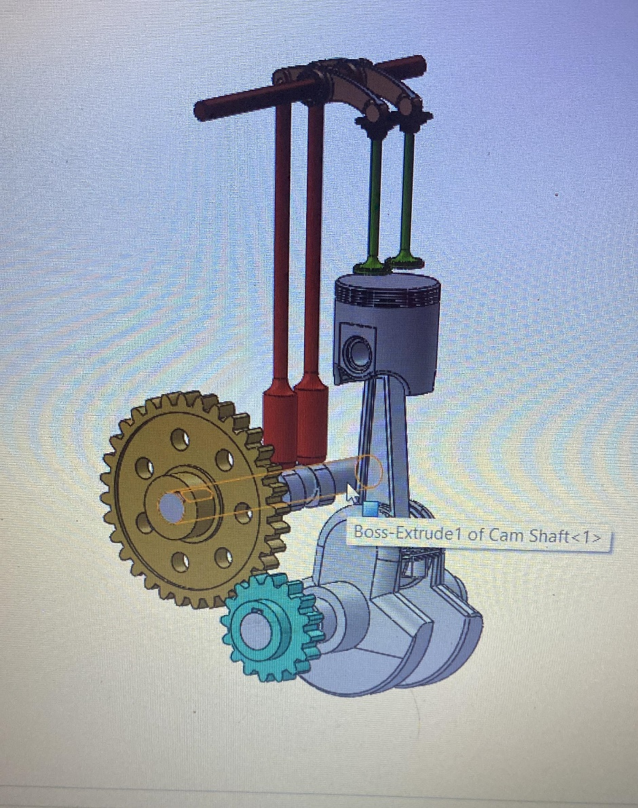
*Components of a Single Cylinder Engine:*
A typical single-cylinder engine consists of several essential components:
1. *Cylinder*: The core of the engine where combustion occurs.
2. *Piston*: A movable component inside the cylinder that compresses the air-fuel mixture and converts reciprocating motion into rotational motion.
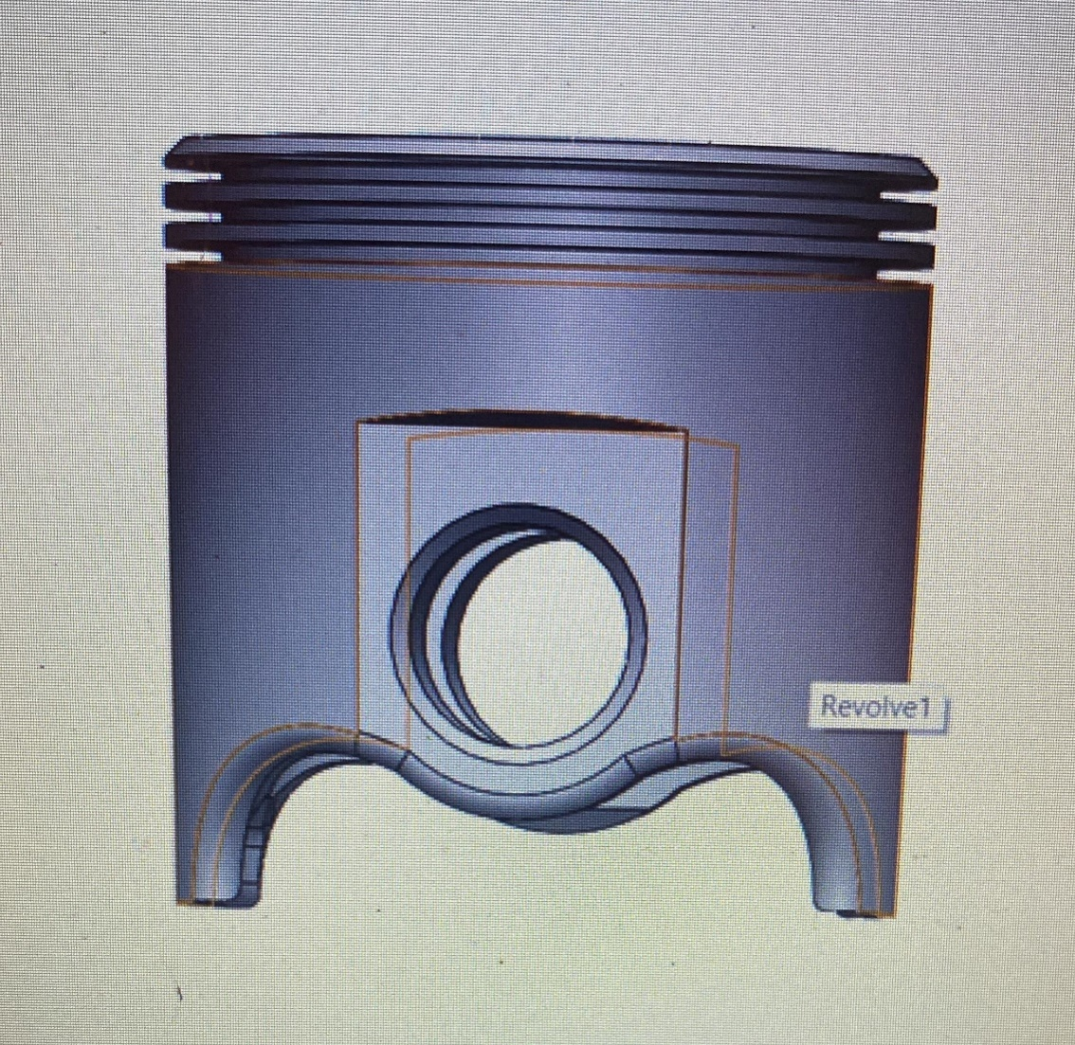
Working
In an internal combustion engine, the piston plays a crucial role in the process of generating power. Here's a simplified overview of the piston's work in an engine:

1. *Intake Stroke*: The piston moves down the cylinder as the intake valve opens. This creates a vacuum, drawing in a mixture of air and fuel into the cylinder.

2. *Compression Stroke*: The piston moves back up the cylinder, compressing the air-fuel mixture. This compression increases the mixture's pressure and temperature, making it more volatile.

3. *Power Stroke*: When the air-fuel mixture is at its most compressed state, a spark plug ignites it. The rapid combustion of the mixture produces a high-pressure force that pushes the piston down the cylinder. This is the stroke where mechanical energy is generated and used to turn the engine's crankshaft.

4. *Exhaust Stroke*: The piston moves back up the cylinder again, but this time the exhaust valve opens. This allows the burned gases from the power stroke to be expelled from the cylinder.

This repetitive cycle of intake, compression, power, and exhaust strokes is what powers the engine and produces mechanical work, which is ultimately used to drive a vehicle or perform other tasks. The piston's movement within the cylinder is a crucial part of this process, converting the pressure generated by the combustion into mechanical energy.

3. *Crankshaft*: Converts the linear motion of the piston into rotary motion, providing power to the output shaft.
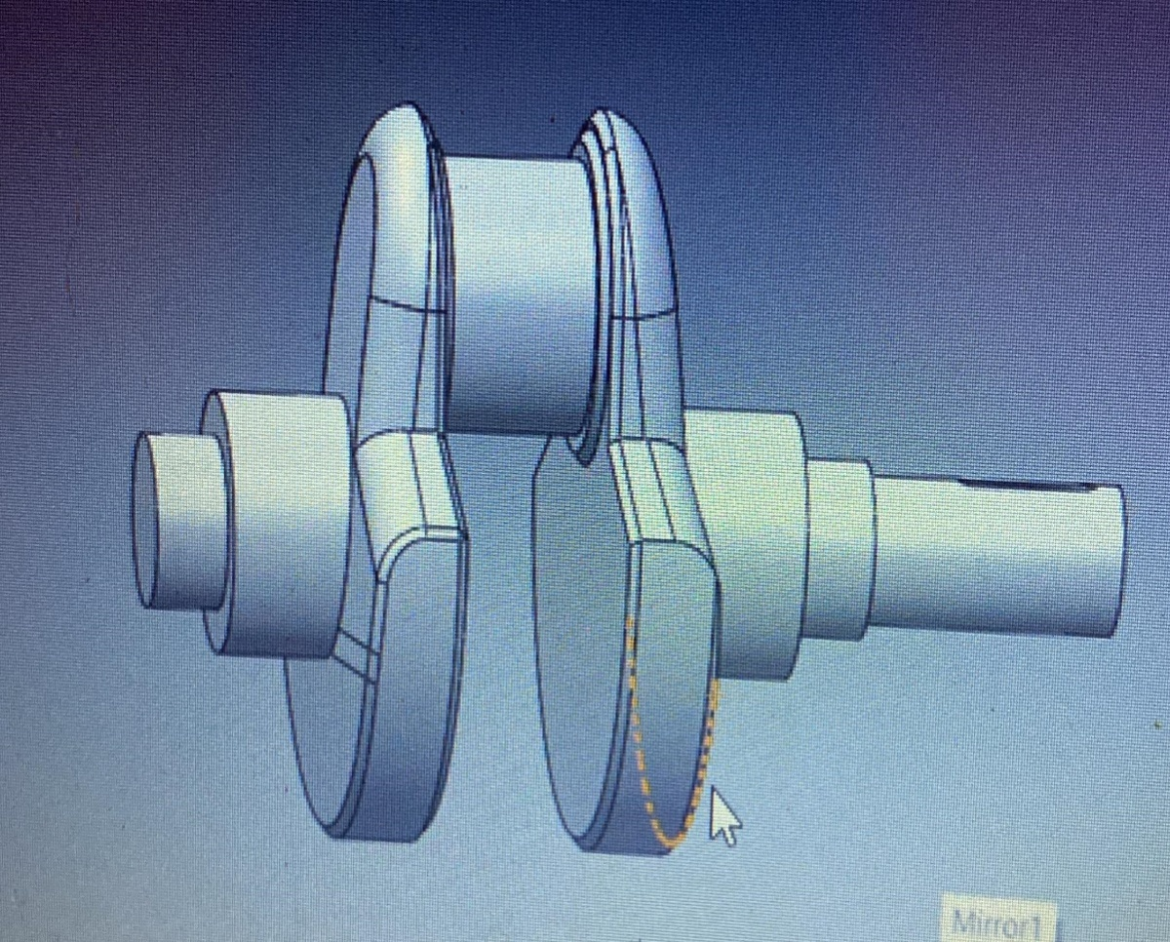
Working
In an internal combustion engine, the piston plays a crucial role in the process of generating power. Here's a simplified overview of the piston's work in an engine:

1. *Intake Stroke*: The piston moves down the cylinder as the intake valve opens. This creates a vacuum, drawing in a mixture of air and fuel into the cylinder.

2. *Compression Stroke*: The piston moves back up the cylinder, compressing the air-fuel mixture. This compression increases the mixture's pressure and temperature, making it more volatile.

3. *Power Stroke*: When the air-fuel mixture is at its most compressed state, a spark plug ignites it. The rapid combustion of the mixture produces a high-pressure force that pushes the piston down the cylinder. This is the stroke where mechanical energy is generated and used to turn the engine's crankshaft.

4. *Exhaust Stroke*: The piston moves back up the cylinder again, but this time the exhaust valve opens. This allows the burned gases from the power stroke to be expelled from the cylinder.

This repetitive cycle of intake, compression, power, and exhaust strokes is what powers the engine and produces mechanical work, which is ultimately used to drive a vehicle or perform other tasks. The piston's movement within the cylinder is a crucial part of this process, converting the pressure generated by the combustion into mechanical energy.

4. **Camshaft:-Controls the timing of valve openings and closings, vital for four-stroke engines.
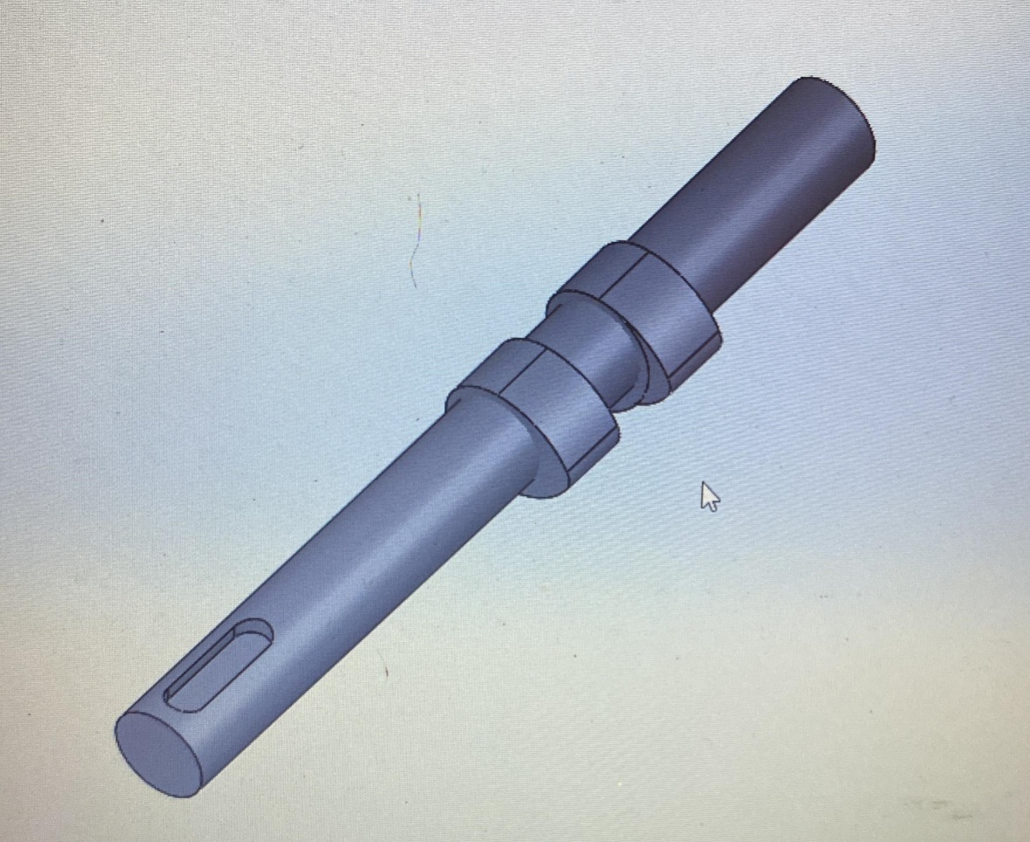
Working
The camshaft is another critical component in an engine, responsible for controlling the opening and closing of the engine's intake and exhaust valves. Here's how a camshaft works:

1. *Camshaft Location*: The camshaft is typically located in the engine block or cylinder head, depending on the engine's design. It is synchronized with the crankshaft's rotation but operates at half the speed, as it makes one complete rotation for every two rotations of the crankshaft.

2. *Cam Lobes*: The camshaft has several cam lobes, each corresponding to a specific valve in the engine. These cam lobes are eccentrically shaped and are designed to open and close the valves at precise moments in the engine's four-stroke cycle (intake, compression, power, exhaust).

3. *Valve Actuation*: As the camshaft rotates, the lobes come into contact with either rocker arms or direct followers (also known as lifters or tappets), depending on the engine's design. The shape of the cam lobes determines the timing and amount of valve lift. When a lobe pushes against a rocker arm or lifter, it causes the corresponding valve to open. When the lobe moves away, a valve spring closes the valve.

4. *Timing and Valve Control*: The camshaft's position and the shape of its lobes are carefully designed to control the precise timing of valve opening and closing. This timing is critical for the engine's performance, efficiency, and emissions control.

5. **Variable Valve Timing (VVT)**: In some modern engines, there is a feature called Variable Valve Timing (VVT). VVT systems can adjust the camshaft's position or alter the camshaft profile to optimize engine performance under different conditions, such as varying engine speeds or loads.

In summary, the camshaft is responsible for precisely controlling the opening and closing of the intake and exhaust valves in an engine. This control of the valves' timing and lift is crucial for the engine's efficient operation, power output, and emissions control. Different camshaft profiles can also be used to tailor an engine's performance characteristics for specific applications.

5. *Valves*: Regulate the flow of air and fuel into the cylinder and the expulsion of exhaust gases.
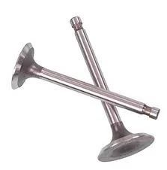
Working
Valves are crucial components in an internal combustion engine, responsible for controlling the flow of air and fuel into the combustion chamber (intake valves) and the flow of exhaust gases out of the combustion chamber (exhaust valves). Here's how intake and exhaust valves work in an engine:

*Intake Valve:*
1. *Valve Closed Position*: During the compression and power strokes of the engine, the intake valve is in the closed position. This prevents the escape of combustion gases and helps build compression within the cylinder.

2. *Valve Open Position*: As the engine's crankshaft and camshaft rotate, a cam lobe on the camshaft pushes against a lifter or rocker arm, which in turn pushes down on the valve stem. This action causes the intake valve to open.

3. *Air and Fuel Intake*: With the intake valve open, the piston's movement creates a vacuum within the cylinder during the intake stroke. This vacuum draws in a mixture of air and fuel from the intake manifold through the open valve and into the combustion chamber.

4. *Valve Closing*: After the intake stroke, the camshaft's profile causes the valve to close. The valve remains closed during the compression and power strokes to seal the combustion chamber.

*Exhaust Valve:*
1. *Valve Closed Position*: During the intake and compression strokes, the exhaust valve is in the closed position. This seals the combustion chamber to prevent the backflow of exhaust gases.

2. *Valve Open Position*: As the engine's camshaft rotates, a different cam lobe pushes against the lifter or rocker arm connected to the exhaust valve. This action causes the exhaust valve to open.

3. *Exhaust Gas Expulsion*: With the exhaust valve open, as the piston moves up during the power and exhaust strokes, it pushes the burned exhaust gases out of the combustion chamber and into the exhaust manifold.

4. *Valve Closing*: After the exhaust stroke, the camshaft profile causes the exhaust valve to close, sealing the combustion chamber for the next cycle.

This cycle of opening and closing the intake and exhaust valves is synchronized with the engine's rotation and is essential for the engine's proper operation. It ensures the timely intake of air and fuel, efficient combustion,

6. Connecting Rod:-A connecting rod in an engine is a rod-shaped component that links the piston to the crankshaft, converting the piston's up-and-down motion into rotational motion to generate power.
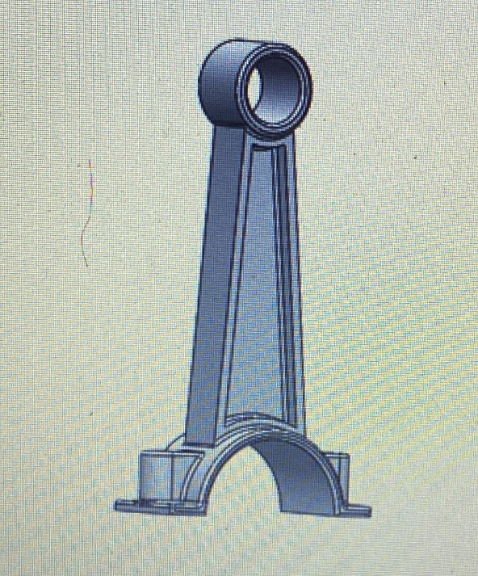
Working
The connecting rod in an engine plays a crucial role in the conversion of reciprocating motion to rotational motion. Here's how it works:

1. *Attachment*: One end of the connecting rod is attached to the piston, typically through a piston pin (wrist pin) connection. The other end is connected to the crankshaft at a throw or crankpin.

2. *Reciprocating Motion*: As the piston moves up and down within the cylinder during the engine's four-stroke cycle (intake, compression, power, exhaust), the connecting rod transmits this reciprocating motion from the piston to the crankshaft.

3. *Rotational Motion*: The reciprocating motion of the piston is converted into rotational motion by the connecting rod. When the piston moves downward (power stroke), it exerts force on the connecting rod, which in turn rotates the crankshaft. This rotation is what ultimately drives the vehicle or powers machinery.

4. *Balancing*: The design of the connecting rod is carefully engineered to ensure that the forces and stresses generated during this motion are balanced and distributed evenly. This balancing is essential to minimize vibrations and ensure smooth engine operation.

In summary, the connecting rod serves as a vital linkage between the reciprocating motion of the piston and the rotational motion of the crankshaft in an engine. This conversion of motion is fundamental to the engine's ability to generate power efficiently.

*Working Principles:*
The operation of a single-cylinder engine is based on the four-stroke cycle, which includes the following phases:
1. *Intake*: The intake valve opens, allowing air (in the case of gasoline engines) or air-fuel mixture (in the case of diesel engines) to enter the cylinder as the piston moves down.
2. *Compression*: The piston moves up, compressing the air or air-fuel mixture, increasing its pressure and temperature.
3. *Combustion*: A spark (in gasoline engines) or high compression (in diesel engines) ignites the mixture, causing a rapid expansion of gases, which forces the piston down.
4. *Exhaust*: The exhaust valve opens, and the piston moves up again, expelling the exhaust gases.
This cycle repeats continuously, creating a continuous supply of mechanical energy, which is then transferred to the output shaft through the crankshaft.
*Significance and Applications:*
Single-cylinder engines play a vital role in various applications, especially where compactness and simplicity are required. They are commonly found in:
- *Motorcycles and Scooters*: Providing lightweight yet efficient power for two-wheelers.
- *Generators*: Offering a portable source of electricity in remote areas or during power outages.
- *Agricultural Machinery*: Driving small tractors and farming equipment.
- *Water Pumps*: Powering pumps for irrigation and water supply.
- *Recreational Vehicles*: Running small boats, ATVs, and snowmobiles.

The single-cylinder engine's compact design and versatility make it an essential component in a wide range of equipment, contributing to the efficiency and productivity of various industries.

- LITERATURE REVIEWS
- H. D. Desai [1] explained that the reciprocating engine mechanism is often analyzed, since it serves all the demands required for the convenient utilization of natural sources of energy, such as steam, gaseous and liquid fuels, for generation of power. Further, it is widely employed as suitable mechanism for pumps and compressors. In this paper the complete kinematic and combined static and inertia force analysis of a horizontal, single cylinder, four stroke internal combustion engine is discussed. The analytical approach is used as it is more accurate and is less time consuming if it is programmed for the computer solution. The data for the analysis of the engine has been taken from the available literature. The present investigation furnishes the complete kinematic history of the driven links and the bearing loads for the complete working cycle of the engine mechanism. The complete force analysis of the engine is simplified by a summation of the static forces and inertia forces ignoring the friction forces which makes the analysis linear. The computer program is prepared in fortran language for both kinematic and dynamic analysis of the engine at the crank interval of 15 deg Vivek.

- C. Pathade et.al [2] recognized that, the automobile engine connecting rod is a high volume production critical component. Every vehicle that uses an internal combustion engine requires at least one connecting rod .From the viewpoint of functionality, connecting rods must have the highest possible rigidity at the lowest weight. The major stress induced in the connecting rod is a combination of axial and bending stresses in operation. The axial stresses are produced due to cylinder gas pressure (compressive only) and the inertia force arising in account of reciprocating action (both tensile as well as compressive), where as bending stresses are caused due to the centrifugal effects. The result of which is, the maximum stresses are developed at the fillet section of the big and the small end. Hence, the paper deals with the stress analysis of connecting rod by Finite Element Method using Pro/E Wildfire 4.0 and ANSYS WORKBENCH 11.0 Software.

- Anil Kumar et.al [4] explained that Aim of this work is to optimize weight and reduce inertia forces on the existing connecting rod, which is obtained by changing such design variables in the existing connecting rod design. The model was developed in Pro / E wildfire 5.0 and then imported as parasolid (xt) form in ANSYS workbench. In this work finite element analysis of the single cylinder four stroke petrol engine connecting rod is considered as case study. The Von Mises stress, strain and total deformation determined for the same loading conditions and compared with the existing results. Based on the observation of static FEA and the load analysis result, the load for the optimization study was selected same as on existing connecting rod. The current work consists of static structural analysis. The static analysis was carried out under axial and buckling load. The model is also selected for fatigue analysis to determine the fatigue strength.
- Gunter Knoll et.al [5] studied that A software package was developed to simulate the dynamics of a flexible crankshaft and a flexible engine block, coupled by nonlinear, distributed, elastohydrodynamic fluid film bearing reaction forces. The Kernel of the developed code is a step size controlled integration of Newton's equations of motion in the time domain. Large rigid body motions and small elastic deformations are separated using special matrix operations. No additional set of equations for the rigid body motion is required. Structural properties of the elastic bodies are represented by stiffness and mass matrices obtained from commercial finite element programs. A combined static (Guyan) and modal reduction scheme is used to limit the number of degrees of freedom, at which gyroscopic, centrifugal and coriolis effects are considered by suited reduced vectors and matrices. An arbitrary number of fluid film bearings can be defined to couple the finite element structures. Various (elasto-) hydrodynamic calculation models can be selected depending on the needs of accuracy and computational speed. In the elastohydrodynamic solution a sub structuring method is employed and Reynolds' equation, including mass conserving cavitation, is solved on the bearing surface of the substructure using finite element methods. The computed results, nodal displacements, velocities, accelerations and forces, lubricant pressure and density distributions, journal orbits etc., indicate the system behavior and support the system optimization. In an exemple studycomputed results are compared to measurements. Test rig runs were done with a four cylinder four stroke 1.8 gasoline engine.
- Amit Solankiet.al [6] explained that the performance of any automobile largely depends on its size and working in dynamic conditions. The design of the crankshaft considers the dynamic loading and the optimization can lead to a shaft specifications with cost and size effectiveness. The.. review of existing literature on crankshaft design and optimization is presented. The materials, manufacturing process, failure analysis, design consideration etc. of the crankshaft are reviewed here.
- Farzin H. Montazersadghand Ali Fatemi [7] presented that a dynamic simulation was conducted on a crankshaft from a single cylinder four stroke engine. Finite element analysis was performed to obtain the variation of stress magnitude at critical locations. The pressure-volume diagram was used to calculate the load boundary condition in dynamic simulation model, and other simulation inputs were taken from the engine specification chart. The dynamic analysis was done analytically and was verified by simulation in ADAMS which resulted in the load spectrum applied to crank pin bearing. This load was applied to the FE model in ABAQUS, and boundary conditions were applied according to the engine mounting conditions. The analysis was done for different engine speeds and as a result critical engine speed and critical region on the crankshaft were obtained. Stress variation over the engine cycle and the effect of torsional load in the analysis were investigated. Results from FE analysis were verified by strain gages attached to several locations on the crankshaft. Results achieved from aforementioned analysis can be used in fatigue life calculation and optimization of this component.

- OBJECTIVES
The main objective in designing a single-cylinder engine is to create a compact, efficient, and reliable power source for various applications, such as motorcycles, small vehicles, generators, and more. Design considerations typically include optimizing power output, fuel efficiency, emissions, and reliability while minimizing size, weight, and cost. Single-cylinder engines are often used in scenarios where simplicity and cost-effectiveness are prioritized, but
design objectives for a single-cylinder engine assembly typically include:
1. Performance: Ensure the engine provides the desired power and torque output for its intended application while optimizing fuel efficiency and emissions.
2. Reliability: they still need to meet performance and environmental requirements.
The Design the engine to operate reliably over its expected lifespan, minimizing the risk of breakdowns and maintenance.
3. Efficiency: Maximize the thermal and mechanical efficiency of the engine to minimize energy losses and improve fuel economy.
4. Durability: Select materials and manufacturing processes that ensure the engine can withstand the stresses and operating conditions it will encounter.
5. Compactness: Design the engine to be as compact as possible to fit within the available space in the application while maintaining performance and efficiency.
6. Noise and Vibration: Minimize noise and vibration levels to improve user comfort and meet regulatory requirements.
7. Emissions: Design the engine to meet or exceed emissions regulations and minimize environmental impact.
8. Cost-effectiveness: Balance performance and features with manufacturing and production costs to make the engine assembly economically viable.
9. Serviceability: Consider ease of maintenance and repair to reduce downtime and maintenance costs.
10. Safety: Ensure the engine assembly meets safety standards and does not pose risks to operators or users.
These objectives may vary depending on the specific application and requirements of the single-cylinder engine.

- ABOUT THE PROJECT
- SPECIFICATIONS
Certainly, here are some general specifications for the design of a single-cylinder engine assembly:
1. Engine Type: Internal combustion, single-cylinder engine.
2. Displacement: Define the engine's displacement in cubic centimeters (cc) or liters (L).
3. Power Output: Specify the desired power output in kilowatts (kW) or horsepower (HP).
4. Fuel Type: Indicate whether it's a gasoline, diesel, natural gas, or other type of engine.
5. Compression Ratio: Specify the compression ratio for optimal combustion.
6. Cooling System: Describe the cooling method, whether it's air-cooled or liquid-cooled.
7. Lubrication System: Detail the lubrication system to ensure proper engine component lubrication.
8. Ignition System: Specify the ignition system, such as spark ignition or compression ignition (diesel).
9. Materials: Define the materials for critical engine components, like the cylinder, piston, and crankshaft.
10. Emissions: Describe any emission control systems or standards the engine needs to meet.
11. Dimensions and Weight: Provide the engine's physical dimensions and weight for integration purposes.
12. Noise Level: Specify the acceptable noise level in decibels (dB) if relevant.
13. Efficiency: Set efficiency targets, such as thermal efficiency and mechanical efficiency.
14. Mounting and Interface: Describe how the engine will be mounted and integrated into its intended application.
15. Safety Features: Identify safety features, such as automatic shutdown mechanisms.
16. Environmental Considerations: Address any environmental considerations, like compliance with emissions regulations.
17. Testing and Validation: Outline the testing procedures and performance criteria for validation.
18. Cost Constraints: If applicable, specify cost constraints and budget limitations.
These specifications will serve as a foundation for the detailed design and engineering of the single-cylinder engine assembly, ensuring it meets your project's requirements and performance goals.
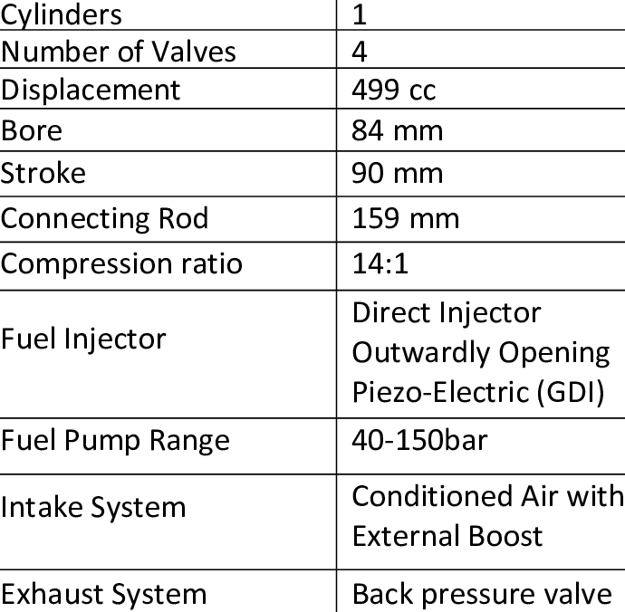

- Methodology
Designing a single-cylinder engine assembly in SolidWorks involves several steps. Here's a methodology to guide you through the process:
Step by Step Procedure for making parts in Solidworks
Creating parts in SolidWorks for the design of a single-cylinder engine involves a systematic approach to ensure accuracy and efficiency. Here's a methodology specifically tailored to the creation of parts for a single-cylinder engine design:
*1. Project Planning:*
- Define the scope of the engine design project and the specific parts you need to create in SolidWorks.
- Identify any design constraints or requirements for each part.
*2. Reference and Research:*
- Gather reference materials, technical specifications, and any existing designs or drawings related to single-cylinder engines.
- Research industry standards and best practices for engine part design.
*3. SolidWorks Setup:*
- Launch SolidWorks and create a new part document.
- Set up your workspace with appropriate units and templates.
*4. Sketching and 2D Profiles:*
- Begin by creating 2D sketches for each part. Use the sketch tools in SolidWorks to draw the profiles and outlines of the parts.
- Ensure that sketches are fully constrained and accurately represent the part's geometry.
*5. Extrusion and Basic Features:*
- Use the Extrude feature to turn your 2D sketches into 3D solids.
- Add basic features such as holes, fillets, and chamfers where necessary to match the design requirements.
*6. Parametric Modeling:*
- Apply parametric modeling principles to your parts. Use dimensions and relations to define key parameters.
- Establish relationships between parts if they need to fit together within the engine assembly.
*7. Part Optimization:*
- Optimize parts for manufacturability and performance. This may involve refining geometries, reducing material usage, or adding features for ease of assembly.
*8. Simulation (if applicable):*
- If any of the parts require simulation, set up and run simulations for stress analysis, thermal analysis, or other relevant tests.
- Make design adjustments based on simulation results.
*9. Material Selection:*
- Choose appropriate materials for each part based on their intended function, durability, and environmental factors.
- Apply material properties within SolidWorks.
*10. Assembly Compatibility:*
- Ensure that each part is compatible with the assembly requirements. Parts should fit together correctly with appropriate clearances and tolerances.
*11. Documentation:*
- Create detailed technical drawings for each part. Include dimensions, tolerances, surface finishes, and any necessary annotations.
- Follow industry standards for dimensioning and tolerancing.
*12. Quality Control and Review:*
- Conduct a thorough review of each part's design, checking for errors, omissions, or inconsistencies.
- Collaborate with team members or experts for additional feedback.
*13. Prototyping (if applicable):*
- Create physical prototypes of critical parts to validate their design and functionality.
- Make any necessary design adjustments based on prototype testing.
*14. Finalization:*
- Ensure that all parts meet the design specifications and project requirements.
- Save and organize SolidWorks files, including part files, assemblies, and drawings.
*15. Collaboration and Integration:*
- Coordinate with other team members working on different parts of the engine to ensure seamless integration during assembly.
*16. Documentation and Reporting:*
- Compile a comprehensive report detailing the design process for each part, including design decisions, revisions, and testing results.
*17. Project Review and Presentation:*
- Present the completed parts to stakeholders or the project team.
- Review the overall progress of the engine design project, addressing any challenges or lessons learned.
This methodology provides a structured approach to creating parts in SolidWorks for a single-cylinder engine design, guiding you through the entire process from initial sketches to final documentation. Customize it as needed to align with the specific requirements of your project.

Step by Step Procedure forassembling parts in Solidworks
Assembling parts in SolidWorks for your project involves organizing and combining individual components to create a functional system or product. Here's a methodology for assembling parts in SolidWorks:

*1. Project Planning:*
- Define the scope of your project and identify the parts that need to be assembled.
- Establish clear objectives and expectations for the assembly process.
*2. SolidWorks Setup:*
- Launch SolidWorks and create a new assembly document.
- Ensure that your workspace and units are set up correctly.
*3. Part Preparation:*
- Before assembling, make sure that all the individual parts are created and saved in SolidWorks.
- Organize your parts in folders or assemblies as needed to maintain a clear structure.
*4. Assembly Design:*
- Begin by inserting the first component into your assembly.
- Use the "Insert Component" command to place each part in its respective position.
- Align and mate the components as necessary to achieve the desired relationships. Common mates include:
- Coincident: Aligning two surfaces or points.
- Concentric: Centering cylindrical features.
- Parallel: Aligning features along the same axis.
- Distance: Specifying the gap or spacing between parts.
- Utilize the "Mate" tool in SolidWorks to apply these relationships accurately.
- Pay attention to proper clearance, alignment, and fitment between parts.
*5. Subassemblies (if applicable):*
- If your project involves complex assemblies, consider creating subassemblies to group related parts together. This simplifies the main assembly.
- Insert subassemblies into the main assembly and mate them accordingly.
*6. Check for Interferences:*
- Use SolidWorks' interference detection feature to identify any collisions or overlaps between parts.
- Resolve interferences by adjusting mates or modifying component geometry as needed.
*7. Motion and Animation (if applicable):*
- If your project involves moving parts or mechanisms, use SolidWorks Motion to simulate and animate the assembly's motion.
- This can help validate functionality and identify any issues early in the design process.
*8. Testing and Validation:*
- Test the assembly's functionality and behavior to ensure that all parts work together as intended.
- Address any issues or conflicts that arise during testing.
*9. Appearance and Visualization:*
- Apply appearances and textures to your assembly for realistic visualization using SolidWorks Visualize or other rendering tools.
- Create exploded views or animations to showcase the assembly's features and functionality.
*10. Documentation:*
- Generate detailed assembly drawings and bills of materials (BOMs) for manufacturing or documentation purposes.
- Include dimensions, tolerances, and annotations following industry standards.
*11. Collaboration and Review:*
- Collaborate with team members or project stakeholders to review the assembly design.
- Incorporate feedback and make necessary revisions.
*12. Finalization:*
- Ensure that all components are correctly assembled and that the assembly meets the project requirements.
- Save and organize your SolidWorks assembly files and related documentation.
*13. Presentation and Reporting:*
- Present the completed assembly to stakeholders or the project team.
- Prepare a report summarizing the assembly process, design decisions, and testing results.
*14. Archiving:*
- Archive all project files, including SolidWorks assembly files, part files, drawings, and reports for future reference or collaboration.
This methodology provides a structured approach to assembling parts in SolidWorks for your project, guiding you through the entire process from importing individual components to creating a functional assembly with proper documentation. Customize it as needed to align with the specific requirements of your project.
Step by Step Procedure formaking drawing views of assembled parts in Solidworks
Creating drawings after assembling parts in SolidWorks is a critical step in documenting your project for manufacturing and reference. Here's a methodology for generating drawings based on an assembled project:

*1. Assembly Completion:*
- Ensure that your assembly is fully constructed and all components are correctly positioned and mated.
*2. SolidWorks Setup:*
- Launch SolidWorks and open the assembly you want to create drawings for.
- Create a new drawing document based on your organization's or project's preferred template and standards.
*3. Drawing Views:*
- Insert the primary view of your assembly into the drawing. Typically, this is an isometric or orthogonal view that shows the entire assembly.
- Add any additional orthographic views (e.g., front, top, side) as necessary to provide a comprehensive representation of the assembly.
*4. Bill of Materials (BOM):*
- If your project involves multiple components, generate a Bill of Materials (BOM) using the "Bill of Materials" tool.
- Customize the BOM to include relevant information, such as part numbers, descriptions, quantities, and materials.
*5. Exploded Views (if applicable):*
- If your assembly requires complex disassembly or maintenance instructions, create exploded views to illustrate component separation.
- Use the "Explode" tool to define the sequence of component movement in the exploded view.
*6. Section Views and Detail Views (if applicable):*
- Insert section views or detail views to highlight specific features, internal components, or complex areas that require detailed documentation.
- Annotate these views with dimensions, notes, and labels as needed.
*7. Dimensioning and Tolerancing:*
- Apply dimensions to critical features of your assembly using the "Smart Dimension" tool.
- Add geometric tolerances (GD&T) or standard tolerances to features as required.
- Ensure that dimensions are placed strategically and follow standard dimensioning practices.
*8. Annotations and Notes:*
- Include annotations and notes to provide additional information, such as assembly instructions, part numbers, finish requirements, and any special considerations.
*9. Title Block:*
- Add a title block to the drawing that includes essential information like project title, revision history, date, designer's name, and organization details.
- Ensure that the title block conforms to your organization's or industry standards.
*10. Cross-Referencing and Balloons:*
- If necessary, use balloons to label components and cross-reference them to the BOM.
- Ensure that there's a clear correlation between the BOM, drawing views, and balloons.
*11. Review and Validation:*
- Conduct a thorough review of the drawing, checking for accuracy, completeness, and adherence to standards.
- Verify that all dimensions are clear, and there are no conflicting or missing information.
- Validate that the drawing accurately represents the assembled project.
*12. Printing and Saving:*
- Print hard copies of the drawing for reference or submission.
- Save the SolidWorks drawing file in an organized folder structure, following your project's file naming and version control conventions.
*13. Documentation and Archiving:*
- Document any changes made to the drawing with proper revision control.
- Archive the drawing files, including all revisions, for future reference and traceability.
*14. Sharing and Collaboration:*
- Share the drawing with relevant team members, stakeholders, or manufacturers.
- Ensure that the drawing files are easily accessible to those who need them.

Results
A single-cylinder engine is a type of internal combustion engine that consists of a single cylinder, which is essentially a cylindrical chamber, where the combustion process occurs. It serves as a fundamental building block for various mechanical devices, such as motorcycles, small vehicles, generators, and certain industrial machinery. This engine design is characterized by its simplicity and compactness, as it contains only one piston and one cylinder.
Softpro Indiahas a very good market in the Educational Training programs. The company is offeringgood services, which is reflected on the satisfaction of the customer. Majority of the trainees are satisfied with the service. It guides us to help to set up and manage a large project. It makes feel free to adjust the recommendations to suit the way we work.
This report covered the preview of our learning path and study materials. The use of AutoCAD has many advantages. It can help to reduce the time it takes to produce the drawing needed in the work environment. AutoCAD software is the most amazing range of mechanical computer aided design tool. It is now considered to be the best according to industry standards that can be obtained for a wide array of designing,
Mechanical Engineering Services and other industrial purposes. The use of AutoCAD may also be relied on heavily in order to create efficiencies within the industries. We explored different materials ranging from text, tutorials and Youtube videos so as get to grips with the finer details of mastering AutoCAD. We were guided by the fact that there is more to learning AutoCAD than drawing simple figures and lines and at the end we made a remark by making a quality project ourself.
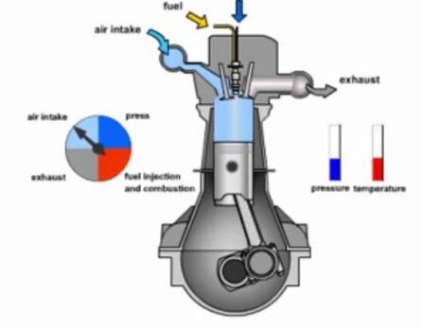

Here's a more detailed breakdown of the components and working principles of a single-cylinder engine:

*1. Cylinder:* The core component of a single-cylinder engine is the cylinder itself, which is typically made of a durable metal like cast iron or aluminum. This cylindrical chamber houses the entire combustion process, from air intake to exhaust.

*2. Piston:* Inside the cylinder, a single piston moves up and down in a reciprocating motion. The piston is connected to a crankshaft, and its movement generates rotational motion, which is harnessed as mechanical work.

*3. Crankshaft:* The crankshaft is connected to the piston via a connecting rod. As the piston moves up and down within the cylinder, it causes the crankshaft to rotate. This rotary motion is the primary output of the engine and can be used to perform various tasks or drive mechanical systems.

*4. Intake and Exhaust Valves:* Single-cylinder engines can have intake and exhaust valves that open and close at specific times in the engine cycle. In a four-stroke engine, which is common in this configuration, there are two valves: the intake valve, which lets in air-fuel mixture, and the exhaust valve, which expels burnt gases.

*5. Ignition System:* In gasoline-powered single-cylinder engines, an ignition system is used to create a spark at the right moment, igniting the air-fuel mixture in the cylinder. In diesel engines, compression ignition occurs due to the high compression of air.

*6. Carburetor or Fuel Injection (for gasoline engines):* Gasoline-powered single-cylinder engines often use a carburetor or fuel injection system to mix air and fuel in the correct proportion before entering the cylinder.

*7. Lubrication and Cooling:* These engines require lubrication to reduce friction between moving parts and cooling to dissipate the heat generated during combustion. Lubricating oil is often added to ensure smooth operation, while air or liquid cooling systems help maintain the engine's temperature within safe limits.

*8. Exhaust System:* After combustion, the exhaust gases exit the cylinder through the exhaust valve and are directed through an exhaust system, which may include a muffler to reduce noise.

Single-cylinder engines are known for their simplicity, which makes them ideal for applications where space and weight constraints are critical. They are commonly found in small vehicles, such as motorcycles and scooters, as well as in portable generators, lawnmowers, and other compact machinery.

While single-cylinder engines may lack the power and smoothness of multi-cylinder engines, their straightforward design and ease of maintenance make them valuable for a range of practical applications, particularly when efficiency and compactness are essential considerations.

- CONCLUSION
Softpro Indiahas a very good market in the Educational Training programs. The company is offeringgood services, which is reflected on the satisfaction of the customer. Majority of the trainees are satisfied with the service. It guides us to help to set up and manage a large project. It makes feel free to adjust the recommendations to suit the way we work.
This report covered the preview of our learning path and study materials. The use of AutoCAD has many advantages. It can help to reduce the time it takes to produce the drawing needed in the work environment. AutoCAD software is the most amazing range of mechanical computer aided design tool. It is now considered to be the best according to industry standards that can be obtained for a wide array of designing,
Mechanical Engineering Services and other industrial purposes. The use of AutoCAD may also be relied on heavily in order to create efficiencies within the industries. We explored different materials ranging from text, tutorials and Youtube videos so as get to grips with the finer details of mastering AutoCAD. We were guided by the fact that there is more to learning AutoCAD than drawing simple figures and lines and at the end we made a remark by making a quality project ourself.

BIBLIOGRAPHY

https://www.google.com/
https://en.wikipedia.org/wiki/Internshala
https://www.autodesk.com/company
https://en. wikipedia. org/wiki/Autodesk
https://www.autodesk.in/products/autocad/
https://en. wikipedia. org/wiki/AutoCAD
https://knowledge.autodesk.com/support/autocad/learn-explore/

